Sample Input 1:

Blue Ford Fusion produced in 2015 featuring a 2.0-liter engine. The vehicle has low mileage with only 40,000 miles on the odometer. Equipped with brand-new all-season tires manufactured in 2022. The car's windows are tinted for added privacy. Notably, the rear bumper has been replaced after a minor collision. Priced at 1 million L.E.

Output 1:

{

    "car": {

      "body_type":"sedan",

      "color": "Blue",

      "brand": "Ford",

      "model": "Fusion",

      "manufactured_year": 2015,

      "motor_size_cc": 2000,

      "tires": {

        "type": "brand-new",

        "manufactured_year": 2022

      },

      "windows": "tinted",

      "notices": [

        {

          "type": "collision",

          "description": "The rear bumper has been replaced after a minor collision."

        }

      ],

      "price": {

        "amount": 1000000,

        "currency": "L.E"

      }

    }

}

Sample Input 2:

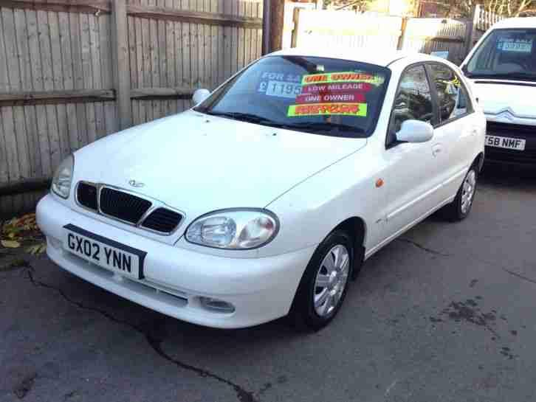

White Daewoo Juliet manufactured at 2001 with a motor size of 1500 cc and the four tires are used they are from 2020. The windows are electrical. There is a small notice the wind shield has been changed due to a small accident. Estimated price is 220K L.E.

Output 2:

{

    "car": {

      "body_type":"hatchback",

      "color": "White",

      "brand": "Daewoo",

      "model": "Juliet",

      "manufactured_year": 2001,

      "motor_size_cc": 1500,

      "tires": {

        "type": "used",

        "manufactured_year": 2020

      },

      "windows": "electrical",

      "notices": [

        {

          "type": "small accident",

          "description": "The wind shield has been changed."

        }

      ],

      "estimated_price": {

        "amount": 220000,

        "currency": "L.E"

      }

    }

}